**Applicant:** GreenovateX

**Inventors:** Sunny Kumar (231053)

**Chemical Product Formula:** C18H35N2NaO4

**Chemical Product Name:** Sodium Lauroamphoacetate

**Process Title:**

**EHS Summary:**

1. List the wastes generated and their quantity of generation.

**Impure Water :**

Water is also generated as a by-product in Amidation reaction.

Flow rate of water produced in

= 2995 mol/day = (2995 X 18.015)/1000

= 53.95 kg/day

**NaCl :**

Nacl is also generated as a by-product in Carboxymethylation reaction.

flow rate of Water produced in esterification

= 2995 mol/day = (2995 X 58.44)/1000 = 175.08 kg/day

Although some amount of lauric acid and Sodium Monochloroacetate are also produced but these chemical are recycled back into the process. So these are not considered as waste.

1. What the current regulations for the above waste materials. (Limits to which it can be disposed in the environment)

**1. Impure Water Disposal Regulations**

Water contamination levels must comply with Central Pollution Control Board (CPCB) India, Environmental Protection Agency (EPA) USA, and EU REACH regulations:

* + - Biological Oxygen Demand (BOD): ≤ 30 mg/L (for disposal into inland surface water)
    - Chemical Oxygen Demand (COD): ≤ 250 mg/L
    - Total Dissolved Solids (TDS): ≤ 2100 mg/L
    - pH Range: 6.5–8.5
    - Oil & Grease: ≤ 10 mg/L

**Treatment & Disposal Methods:**

* + - **Primary Treatment:** Filtration & sedimentation to remove solids.
    - **Secondary Treatment:** Biological treatment to reduce organic load.
    - **Tertiary Treatment:** Reverse osmosis or chemical oxidation to meet discharge standards.
    - **Final Disposal:** Treated water can be reused or discharged into water bodies after meeting permissible limits.

**2. NaCl Disposal Regulations**

While NaCl is not classified as a hazardous waste, its disposal must be managed to

prevent environmental issues like soil salinity and water contamination.​

* **Total Dissolved Solids (TDS) Limit for Disposal in Water Bodies:** ≤ 2100 mg/L
* **Sodium Concentration Limit:** ≤ 200 mg/L (for inland surface water discharge)
* **Disposal in Landfills:** Should be in **secured landfill sites** to prevent groundwater contamination.
* **Recycling Potential:** Can be reused in industrial processes, such as textile and chemical manufacturing.

**Disposal Guidelines:**

* **Land Disposal:** Solid waste containing NaCl should be disposed of in secure landfills designed to prevent leaching into groundwater.​

1. Describe the treatment procedure for wastes with block diagram. Your chemical plant must be a zero liquid discharge plant.

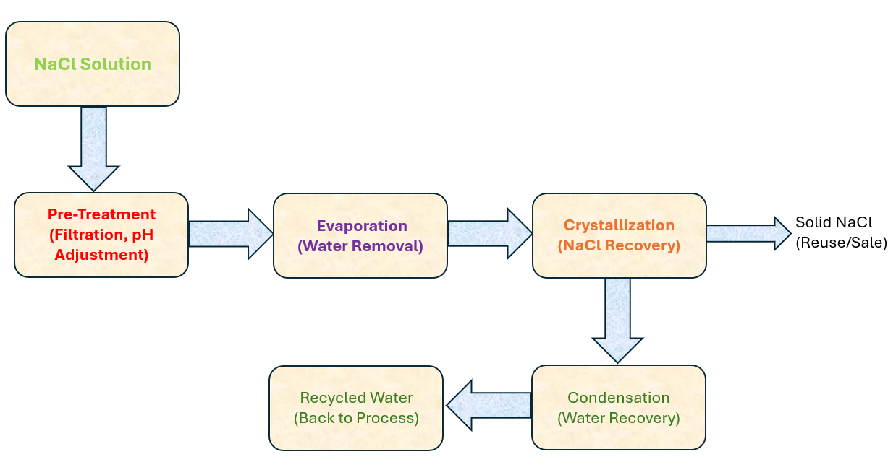

1. Are there any safety concerns for the chemicals. Give exposure limits: Time Weighted Average (TWA) for 8 hours and short-term exposure limit (STEL) for 15 minutes.

|  |  |  |  |
| --- | --- | --- | --- |
| **Chemical** | **Healths Concerns** | **TWA** | **STEL** |
| **Lauric Acid** | Causes eye damage  Toxic to aquatic life | No data | No data |
| **AEEA** | Causes severe skin burns  Risk of serious damage to eyes  May cause respiratory irritation | ACGIH : 2 ppm | ACGIH : 4 ppm |
| **Amidoamine** | Undiluted substance causes mild skin irritation  Causes weak to strong eye damage | 0.1–1mg/m³ | No data |
| **Sodium Monochloroacetate** | Toxic if swallowed  Causes skin irritation  Causes serious eye irritation  Very toxic to aquatic life | ACGIH : 0.1 ppm | ACGIH : 0.3ppm |

**References:** Provide reference for a material safety data sheet/industrial safety report/weblink.

[Home - ACGIH](https://www.acgih.org/)

[ANNEXURE-I](https://cpcb.nic.in/displaypdf.php?id=R2VuZXJhbFN0YW5kYXJkcy5wZGY=)

<https://www.fishersci.com/content/dam/fishersci/en_US/documents/programs/education/regulatory-documents/sds/chemicals/chemicals-l/S25377.pdf>

[2c4bec15-a0af-4ec7-9073-68492eac6cba.pdf](https://saas-tw-fs.usequantum.com/upload/2c4bec15-a0af-4ec7-9073-68492eac6cba.pdf)

<https://chemical.kao.com/content/dam/sites/kao/chemical-kao-com/global/pdf/sustainability/saicm/article_05/SafetySummary_glen_Amidoamine.pdf>

<https://pubchem.ncbi.nlm.nih.gov/compound/Sodium-chloroacetate#section=GHS-Classification>

**List the contributions of each author:**

* Sunny Kumar determined the waste generation quantity.
* Sunny Kumar carried out the literature search and found the current regulations.
* Sunny Kumar found necessary treatment steps and prepared the block diagram.
* Sunny Kumar obtained TWA and STEL data.

**Sign the pdf and upload.**

|  |  |  |
| --- | --- | --- |
| Name | Roll No | Signature |
| Aditya Singh | 230079 |  |
| Sunny Kumar | 231053 |  |